Shiftbase Template
Absence & leave request policy
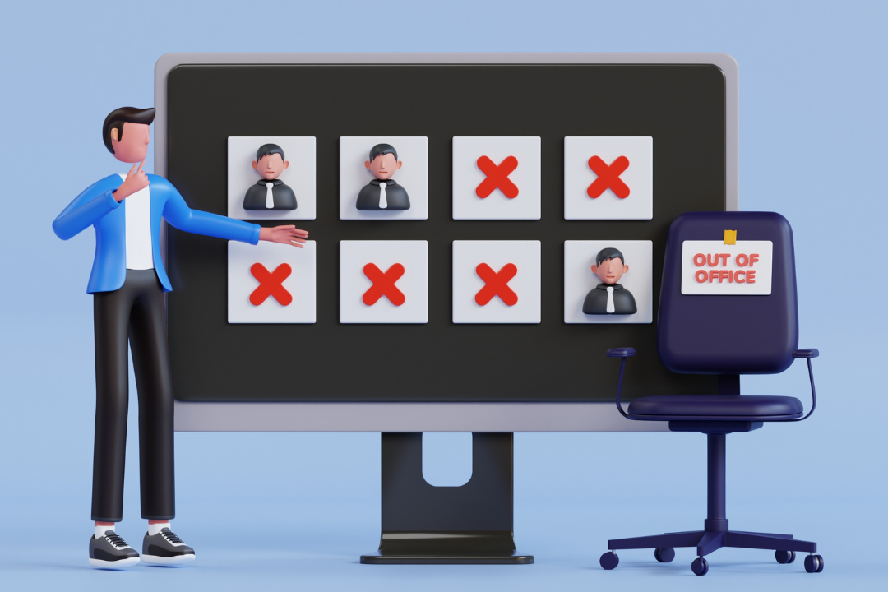

About this template
This template is for SME owners, managers, and HR who need one clear process for leave requests and unplanned absences, so approvals don’t happen in 10 different places.
What this covers
- Planned leave (vacation/PTO and other leave types you approve in advance)
- Unplanned absence (sick/emergency)
- Approval rules, documentation rules, and how it reaches payroll

How to use it (20-minute setup)
- Fill in the placeholders: request channel, approval roles, notice periods, payroll cutoffs
- Decide which leave types you offer and what documentation you require (keep it minimal)
- Publish “one source of truth” for leave balances/requests
- Tell managers: no side approvals in DMs — if it isn’t logged, it isn’t approved
⚠️Important note
Leave rules vary by country/state. This is a global-friendly policy template. Add a local addendum where required.

Policy: Absence & leave requests

Purpose | Make leave fair, predictable, and easy to manage — while keeping schedules covered and payroll accurate.
Scope | Applies to all employees. Contractors follow [policy/process] if applicable.

Leave types (choose what applies)
Include your actual list here (keep it simple):
- Vacation / PTO
- Sick leave
- Unpaid time off
- Family/care leave
- Bereavement leave
- Jury duty / civic duty
- Other: [ ]
⚠️Important note: (If you’re global, keep details in a local addendum per country/state.)

One source of truth (where requests must be logged)
All leave requests and absences must be submitted and approved via:
[tool/form/email alias]
Approved leave is visible in: [calendar/tool].
‼️Rule: if it isn’t logged, it isn’t approved.

Planned leave requests (vacation/PTO, appointments, etc.)
How to request
- Submit request at least [X days/weeks] in advance (where possible).
- Include: dates, type of leave, and any shift coverage notes (if relevant).
‼️Approval rules
- Approver: [manager role]
- Approval criteria (keep consistent):
  - Staffing requirements for the period
  - Fairness (avoid the same people always getting denied)
  - Business critical dates/blackout periods (if you use them)
Response time
Managers respond within: [X business days].
Blackout periods (optional)
If you have peak seasons where leave is limited, list them here: [dates/periods].
‼️Rule: blackout doesn’t mean “no leave ever,” it means “extra review required.”

Unplanned absences (sick/emergency)
How to report
Report as soon as possible, ideally [X minutes/hours] before shift start, via:
[phone number / contact / tool]
Required info (minimum)
- Are you unable to work today? (yes/no)
- Expected duration (if known)
- Any urgent handover notes (if applicable)
❌What not to require
Don’t ask for sensitive details. “Sick” is enough unless local law requires documentation.
No-call/no-show
If there’s no contact within [X hours] of shift start, it’s treated as a no-call/no-show and follows the attendance policy process.

Documentation (keep it minimal and respectful)
Documentation may be required for:
- Absences longer than [X days]
- Certain leave types where local law requires proof
- Patterns that require HR review (handled carefully)
Where documentation is stored: [secure location/tool]
Access is limited to: [roles]

Leave balances and accrual (if applicable)
Leave balances are tracked in: [tool/system].
Employees can view their balance via: [how].
‼️Rules:
- Balance updates after approvals and payroll processing.
- If there’s a discrepancy, contact: [HR/payroll contact].

Scheduling coverage (who does what)
- Employee: requests leave early and shares any relevant handover notes.
- Manager: approves/declines, ensures coverage, updates schedule.
- HR/payroll: ensures leave records flow into payroll correctly.
Optional: coverage expectations (only if appropriate for your culture)
- Employees may be asked to propose coverage swaps, but approval still sits with managers.

Changes, cancellations, and early returns
Change/cancel planned leave
- Submit a change request via [tool] at least [X days] before the leave starts (where possible).
- Manager approves changes based on scheduling impact.
Return earlier than expected (unplanned absence)
- Notify manager via [channel] and confirm schedule updates.

Payroll cutoff (so there are no surprises)
Leave and absence entries must be approved by: [date/time] each pay period.
Anything after cutoff may roll into the next payroll cycle.

Policy enforcement (fair + consistent)
We apply this policy consistently. Misuse or repeated failure to follow the process may lead to coaching and follow-up under the attendance/discipline process.

Policy header (keep this at the top)
Owner: [Name]
Last updated: [Date]
Next review: [Date]
Where it lives (source of truth): [Link/location]

➕ Add-ons
Copy paste tools for smoother processes

Leave request message (if you use email/chat as the channel)

Subject: | Leave request
Type of leave:
Dates/times:
Coverage notes (if relevant):
Anything time-sensitive for approval:

Sick absence message (employee-friendly)

Subject: | I’m sick / can’t work today
Shift/date:
I’m absent today: yes/no
Expected return (if known):
Any urgent handover notes:

Manager approval checklist (30 seconds)
- Is the request logged in the system?
- Can we cover the shift(s) without overtime spikes?
- Is approval consistent with how we handled similar requests?
- Has the schedule been updated and employee notified?
- Is payroll cutoff respected?

Try Shiftbase 14 days for free
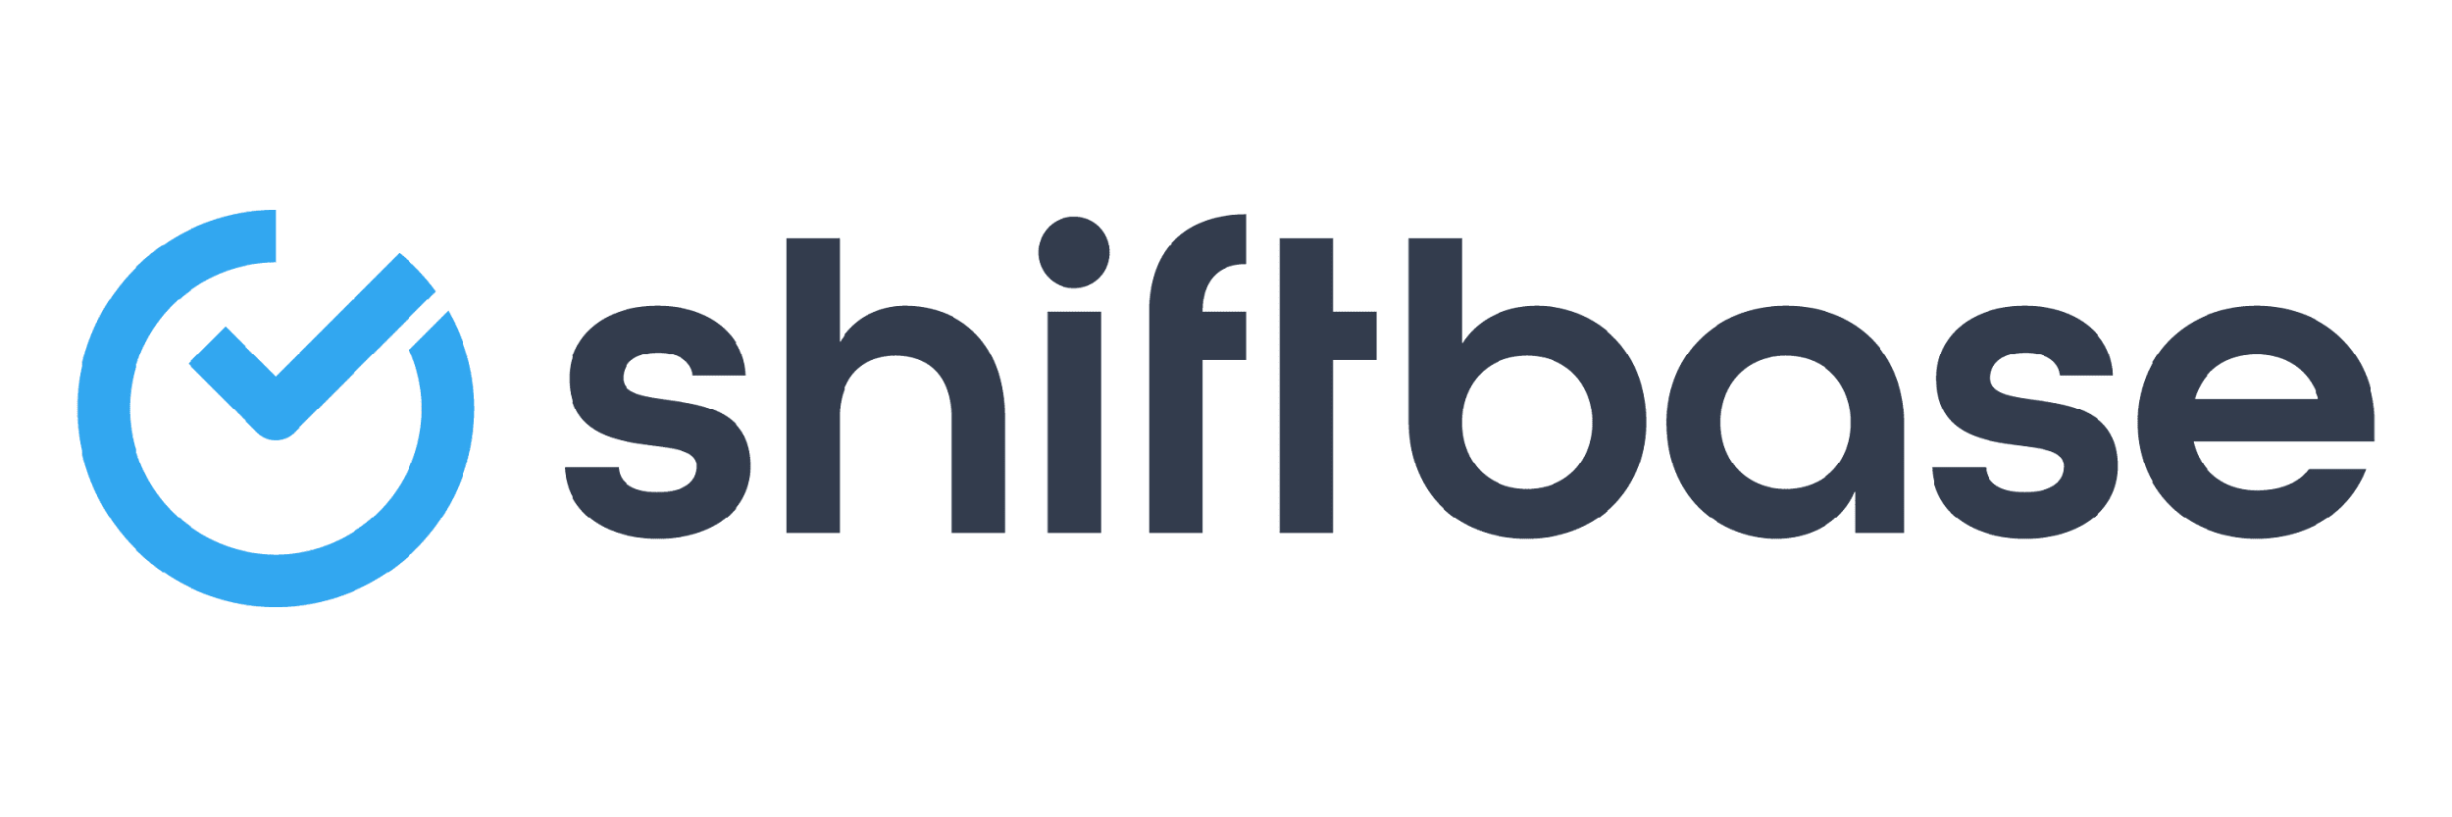
TRY SHIFTBASE FOR FREE AND WITHOUT OBLIGATION FOR 14 DAYS
Discover the comprehensive HR features of Shiftbase and see how you can manage all your employee data in one place. With Shiftbase, you can create detailed analyses of your business performance, gaining valuable insights into your company. Benefit from customizable reports and dashboards that provide you with a real-time overview of your entire company. Experience for yourself how Shiftbase simplifies your HR processes and optimizes your company management.
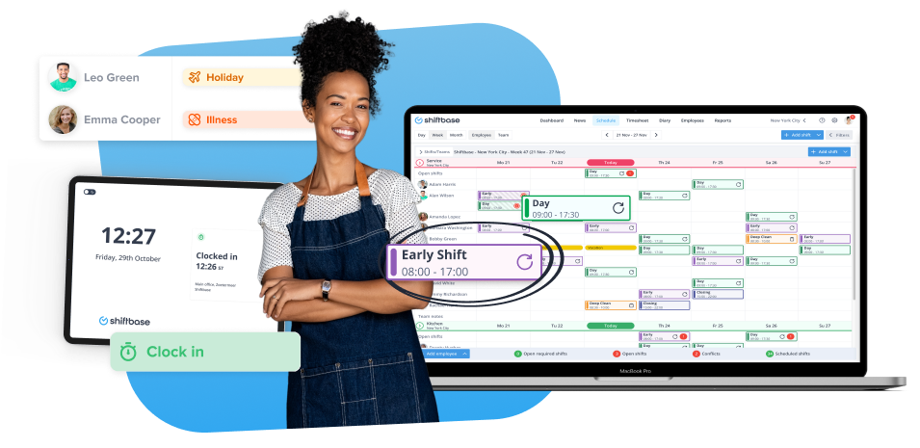

TRY IT NOW FOR FREE

