Shiftbase Template
Discipline & grievances Basics + Process


About this template
This template is for SME owners, managers, and HR who want a clear, repeatable way to handle performance/conduct issues and employee concerns, without improvising every time.
What it helps you do
- Treat people consistently (same steps, same standards)
- Document decisions in a fair, defensible way
- Resolve issues faster with less stress and fewer misunderstandings
How it works
- Discipline = how you respond to performance or conduct issues (with clear expectations + documentation).
- Grievance = how employees raise concerns and how you investigate and respond.
How to use it (15-minute setup)
- Fill in the placeholders: owners, timelines, and where records live
- Decide which steps are “standard” vs when you can skip steps (serious misconduct)
- Train managers on the basics: facts-only notes, consistency, and privacy
- Use the checklists below so nothing gets missed
⚠️ Important note:
Employment rules vary by country/state. Use this as a practical baseline and add a local addendum where needed.

Discipline (performance or conduct)

Principles (non-negotiables)
- Consistency: similar situations → similar outcomes
- Facts over opinions: document what happened, not what you assume
- Right to respond: employees can explain their side
- Proportional response: outcome matches severity and history
Privacy: share details only with people who need to know

Quick classification (so you don’t overreact or underreact)
Use this to choose the right path:
Performance issue: | Not meeting expectations, quality, reliability, missed targets
Conduct issue: | Behavior, attendance patterns, policy breaches, conflict
Serious misconduct: | Theft, violence, serious harassment, major safety breaches (may require immediate action)

Discipline process (step-by-step)
Step 1 — informal conversation (often enough for first-time issues)
Goal: clarify expectations and agree on next steps.
Document: date, topic, expectations, support offered, follow-up date.
Step 2 — formal warning (if issue repeats or is more serious)
Include:
- Specific facts/examples (dates, impact)
- Expected change + deadline
- Consequences if not met
- Document: warning type (verbal/written), employee response, improvement plan, review date.
Step 3 — final warning / improvement plan (if required)
Include:
- Clear goals + timeframe
- Support offered (training, coaching, schedule adjustments if appropriate)
- Check-in cadence
- Document: plan, dates, progress notes, outcomes.
Step 4 — outcome decision
Possible outcomes: training, role adjustment, final warning, termination (depending on severity and local law).
Document: decision maker, rationale, effective date, appeal option (if applicable).

Serious misconduct (when you may skip steps)
If there’s a major breach, you may move straight to formal action. Still do the basics:
- Secure safety first
- Document facts and evidence
- Allow employee response when possible
- Follow local legal requirements and internal policy

Grievances (employee concerns)

What counts as a grievance:
Concerns about treatment, working conditions, conflicts, pay issues, policy application, harassment/discrimination, safety, or other workplace problems.

Grievance process (simple + consistent)
Step 1 — Receive and log
Capture: Who, what, when, where, desired outcome (if known).
Step 2 — Acknowledge receipt
Within: [X business days].
Confirm next steps and expected timeline.
Step 3 — Assign an owner/investigator
Choose someone neutral (avoid conflicts of interest).
Step 4 — Gather information
Employee statement, witnesses, relevant documents, timelines.
Step 5 — Decide and respond
Within: [X days] where possible.
Explain outcome, actions taken, and what happens next.
Step 6 — Appeal route (recommended)
Allow an appeal within: [X days], handled by a different decision maker if possible.

➕ Add-ons

Documentation guide (facts-only cheat sheet)
When writing notes, include:
- What happened (observable facts)
- When/where it happened
- Who was involved / witnesses
- What policy/expectation applies
- What was said (key quotes if needed)
Next steps + deadline
Avoid: labels (“lazy,” “bad attitude”), assumptions, or emotional language.

Meeting checklist (discipline or grievance)
- Confirm who attends (manager, HR, note-taker)
- Explain purpose of the meeting
- Share the facts and allow response
- Agree on next steps and timeline
- Confirm how it will be documented and stored
- Close with a recap (what happens next + when)

Case file structure (one place, consistent every time)
Create one folder/case record per issue:
- Timeline of events
- Notes and evidence
- Meeting notes
- Decisions + rationale
- Follow-up actions + completion dates

Copy/paste templates (manager-ready)

Informal conversation follow-up (message/email)
Subject: Follow-up on our conversation
Hi [Name],
Thanks for speaking today. To recap: the expectation is [X]. Starting from [date], we’ll do [Y]. We’ll review this on [date]. If you need support with [Z], let me know.
— [Manager]

Grievance acknowledgement
Subject: We’ve received your grievance
Hi [Name],
Thanks for raising this. We’ve logged your concern and will review it. Your point of contact is [Name]. We expect to share an update by [date]. If you have supporting details, you can send them to [channel].
— [Name/HR]

⚠️ Important note:
UK employers often align grievance handling with ACAS guidance. In the US, termination and disciplinary expectations can vary by state and contract type — add a local addendum if needed.

Try Shiftbase 14 days for free
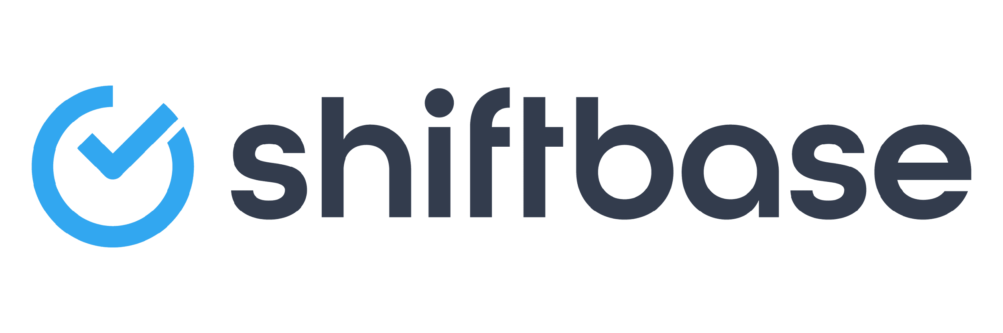
TRY SHIFTBASE FOR FREE AND WITHOUT OBLIGATION FOR 14 DAYS
Discover the comprehensive HR features of Shiftbase and see how you can manage all your employee data in one place. With Shiftbase, you can create detailed analyses of your business performance, gaining valuable insights into your company. Benefit from customizable reports and dashboards that provide you with a real-time overview of your entire company. Experience for yourself how Shiftbase simplifies your HR processes and optimizes your company management.
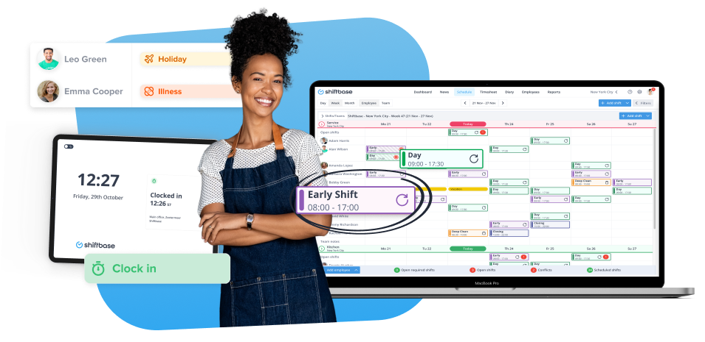

TRY IT NOW FOR FREE

