Shiftbase template  
Exit Interview Template  


# 

# 

# 

# About this template

Conducting and documenting exit interviews is an essential task in the area of ​​human resources management in order to ensure transparency and comprehensibility in corporate communication. This process includes planning, implementing and analyzing the conversations as well as offering protocol templates to support them.

The aim is not only to create clarity through professional discussions, but also to emphasize the appreciation towards departing employees.

This structured template provides guidance for managers to have meaningful final conversations with departing employees and promote positive team relationships.

# 

# Exit interview template

|  |  |
| --- | --- |
| **Exit interview template** | |
| Employee: | Date: |
| Department: | Manager: |
| Entry date: | Exit date: |
| **What were the highlights of your work here?** | |
| **What aspects of your work did you find less appealing?** | |
| **Reasons for deciding to leave the company:**   * Better career opportunities elsewhere * Higher salary with another employer * Dissatisfaction with the corporate culture * Lack of development opportunities * Personal reasons (e.g. moving, family obligations) * Dissatisfaction with leadership * Looking for a new professional challenge * Workload too high or too low * Conflicts within the team or with superiors * Other   In case of 'Other', kindly elaborate on your selection in more detail: | |
| **How could we have prevented your departure?** | |
| **What career opportunities are you particularly interested in?** (Please mark all relevant options)   * Change of industry * Change of position * Increased responsibilities * Working abroad * Special projects * Further training and development opportunities   In case of 'Other', kindly elaborate on your selection in more detail: | |

**Assessment standard**

1 = completely true

2 = mostly applies

3 = rather true

4 = not really true

5 = does not apply

|  |  |  |  |  |  |
| --- | --- | --- | --- | --- | --- |
| **How would you rank your work tasks/ responsibilities** | | | | | |
|  | 5 | 4 | 3 | 2 | 1 |
| My tasks were interesting | ☐ | ☐ | ☐ | ☐ | ☐ |
| Working independently was possible. | ☐ | ☐ | ☐ | ☐ | ☐ |
| Contribution of knowledge and skills was given. | ☐ | ☐ | ☐ | ☐ | ☐ |
| I found the workload to be suitable | ☐ | ☐ | ☐ | ☐ | ☐ |

|  |  |  |  |  |  |
| --- | --- | --- | --- | --- | --- |
| **Experience with the company culture and working environment** | | | | | |
|  | 5 | 4 | 3 | 2 | 1 |
| The company culture was open and welcoming. | ☐ | ☐ | ☐ | ☐ | ☐ |
| I felt that the work environment encouraged creativity. | ☐ | ☐ | ☐ | ☐ | ☐ |
| There was a high work ethic and team spirit | ☐ | ☐ | ☐ | ☐ | ☐ |
| The work-life balance was supported by the company. | ☐ | ☐ | ☐ | ☐ | ☐ |
| There was room for personal growth and suggestions for improvement were appreciated | ☐ | ☐ | ☐ | ☐ | ☐ |

|  |  |  |  |  |  |
| --- | --- | --- | --- | --- | --- |
| **Feedback on manager and teamwork** | | | | | |
|  | 5 | 4 | 3 | 2 | 1 |
| The manager communicates clearly and supports the team effectively. | ☐ | ☐ | ☐ | ☐ | ☐ |
| I feel valued and integrated into the team | ☐ | ☐ | ☐ | ☐ | ☐ |
| The teamwork was productive and motivating | ☐ | ☐ | ☐ | ☐ | ☐ |
| Conflicts within the team were resolved fairly and constructively | ☐ | ☐ | ☐ | ☐ | ☐ |
| My opinions and ideas were valued by the manager and the team | ☐ | ☐ | ☐ | ☐ | ☐ |

|  |  |  |  |  |  |
| --- | --- | --- | --- | --- | --- |
| **Assessment of personal development opportunities in the company** | | | | | |
|  | 5 | 4 | 3 | 2 | 1 |
| The company offered a wide range of further training opportunities | ☐ | ☐ | ☐ | ☐ | ☐ |
| I had plenty of opportunities to use and expand my skills and knowledge | ☐ | ☐ | ☐ | ☐ | ☐ |
| My career goals were supported within the company | ☐ | ☐ | ☐ | ☐ | ☐ |
| Feedback on my performance was constructive and promoted my professional development | ☐ | ☐ | ☐ | ☐ | ☐ |
| There were clear career paths and opportunities for advancement within the company | ☐ | ☐ | ☐ | ☐ | ☐ |

|  |
| --- |
| **Do you have any suggestions on how we as a company could improve the workplace?** |

# 

___________________________ _______________________

Date, signature of manager Date, signature of employee

# 

# Try Shiftbase 14 days for free

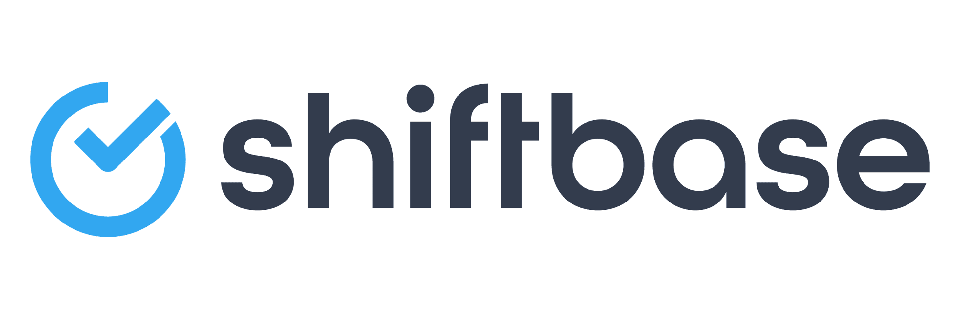

**TRY SHIFTBASE FOR FREE AND WITHOUT OBLIGATION FOR 14 DAYS**

Discover the comprehensive HR features of Shiftbase and see how you can manage all your employee data in one place. With Shiftbase, you can create detailed analyses of your business performance, gaining valuable insights into your company. Benefit from customizable reports and dashboards that provide you with a real-time overview of your entire company. Experience for yourself how Shiftbase simplifies your HR processes and optimizes your company management.

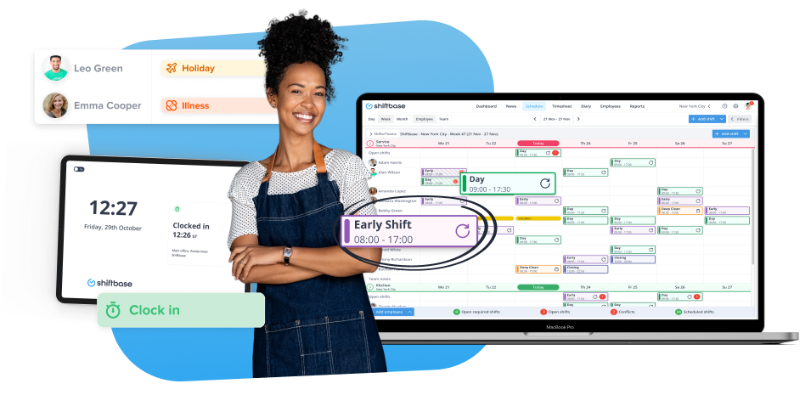

[TRY IT NOW FOR FREE](https://app.shiftbase.com/signup?plan=premium&language=en&signup_cta_source=hero-main&signup_cta_url=https:%2F%2Fwww.shiftbase.com)