Shiftbase Template
Holiday Request & Refusal Policy


Holiday Request & Refusal Policy

A template for UK employers

How to use this template
Replace every [highlighted field] with your own details, then delete this box before you share the policy. The notice rules and record-keeping duty below reflect UK law as of 2026. This template is a starting point, not legal advice; check anything you’re unsure about with a qualified adviser or ACAS.

Company name | [Company Name]
Policy owner | [Name / role]
Effective date | [DD/MM/YYYY]
Next review date | [DD/MM/YYYY]
Applies to | [All employees / all shift-based staff / specify]

1. Purpose
This policy explains how to request annual leave at [Company Name], how we decide requests, and what happens when we cannot approve them. Our aim is to deal with every request fairly, consistently, and in line with UK law.

2. Your holiday entitlement
Your full holiday entitlement is [28] days per leave year, [including / excluding] bank holidays.
Our leave year runs from [1 January] to [31 December].

Guidance: the UK statutory minimum is 5.6 weeks (28 days for a five-day week). Part-time, irregular-hours and part-year staff accrue leave pro rata.

3. How to request leave
Submit your holiday request through [Shiftbase / your system].
Give at least [X weeks] notice. As a guide, give notice of at least twice the length of the leave you want to take, unless we agree otherwise.
You’ll get a decision within [X] working days.

Guidance: requesting early gives you the best chance of getting the dates you want, especially in busy periods.

4. How we decide requests
When more people ask for the same dates than we can release, we use the method ticked below. We apply it the same way for everyone and record how each decision was made.
[ ] First come, first served — requests are approved in the order we receive them.
[ ] Rota-based priority — priority for popular dates rotates each year, so the same people aren’t always first.
[ ] Seniority / length of service — longer-serving staff get first choice.

Guidance: apply a seniority rule with care. If it consistently favours older, longer-serving staff it can raise indirect age-discrimination questions under the Equality Act 2010.

5. Peak and restricted periods
During [list peak periods, e.g. December, July–August], leave is limited and some dates may be restricted.
No more than [X] team members (or [X]% of a team) can be off at the same time.
We’ll tell you about any company shutdown dates at least [X weeks] in advance.

6. If we have to refuse or cancel leave
We can refuse a request for a genuine business reason, such as a peak period, too many staff already off, short notice, or not enough remaining entitlement.
• If we refuse, we’ll give you notice at least as long as the leave you asked for (for example, [5] days’ notice for a [5]-day request), confirmed in writing with the reason.
• If we cancel leave we’ve already approved, we’ll give you notice at least as long as the holiday booked and, where possible, offer alternative dates.
• We won’t stop you taking your full statutory entitlement within the leave year.

Guidance: the counter-notice rule comes from the Working Time Regulations 1998. Late or verbal refusals are the most common source of disputes, so always confirm in writing and on time.

7. Record-keeping
We keep a record of every holiday request, the decision, and the reason behind it. Records are kept for [six] years.

Guidance: from 6 April 2026, the Employment Rights Act 2025 requires UK employers to keep adequate annual-leave and holiday-pay records for six years. Failure is a criminal offence enforceable by the Fair Work Agency.

8. Questions
If anything’s unclear, speak to [Name / role] or email [email address].

Acknowledgement
I confirm I’ve read and understood the [Company Name] Holiday Request & Refusal Policy.

Employee name: __________________________________
Signature: _____________________________________
Date: ___________________________________________

Try Shiftbase 14 days for free
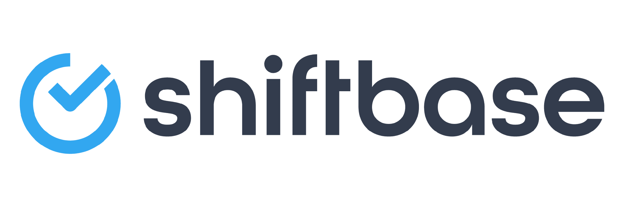
TRY SHIFTBASE FOR FREE AND WITHOUT OBLIGATION FOR 14 DAYS
Discover the comprehensive HR features of Shiftbase and see how you can manage all your employee data in one place. With Shiftbase, you can create detailed analyses of your business performance, gaining valuable insights into your company. Benefit from customizable reports and dashboards that provide you with a real-time overview of your entire company. Experience for yourself how Shiftbase simplifies your HR processes and optimizes your company management.
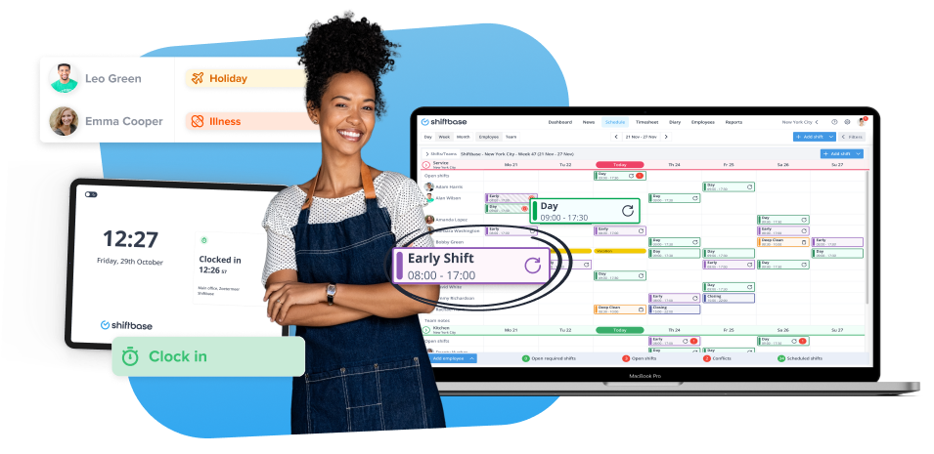

TRY IT NOW FOR FREE

