Shiftbase sample template
Shift changes Protocol


About this sample template

A clear and consistent protocol for shift swapping is a key component of reliable and transparent staff planning. By establishing in advance the conditions under which shifts can be swapped and how the process works, you prevent ambiguity, misunderstandings, and ad hoc decision-making within the organization.

This sample template will help you create a shift swap protocol that provides clarity for both employees and planners. The template provides a structured framework that includes conditions, responsibilities, decision-making, and documenting swap requests.

This template will help you create a legally sound protocol that remains practically applicable. Whether you're establishing agreements about exchanging services for the first time or want to update an existing protocol, this template will help you arrive at clear and consistent agreements.

Exchange protocol services

1. Purpose and scope
This protocol aims to define the conditions and procedures under which employees can swap shifts. It aims to ensure business continuity and provide clarity regarding responsibilities and decision-making regarding schedule changes.

2. Scope
This protocol applies to all employees who are scheduled to work within the organization and who wish to submit a request to swap a shift with a colleague.

3. General principles
- Exchanging services is only permitted after prior approval by the planner.
- No rights can be derived from this protocol by employees.
- The organization reserves the right to refuse exchange requests if this is deemed necessary in the interest of business operations.

4. Conditions for exchanging a service
- A service can only be exchanged if all of the following conditions are met:
- The exchange request must be submitted no later than[x hours or x days]before the start of the relevant service.
- The exchange takes place with a colleague who can demonstrably be qualified and deployed for the same position and activities.
- Both employees agreed to the swap prior to the request.
- The exchange does not lead to exceeding working hours, rest periods or other applicable agreements.
- The exchange has no adverse consequences for the occupancy, quality or safety of the work.

5. Exchange request procedure
- The employee submits an exchange request through the channel designated by the organization.
- The planner will assess the exchange request based on this protocol and the applicable schedule agreements.
- The planner decides whether to approve or reject the exchange request.
- The decision is recorded in the planning.
An exchange only becomes effective once it has been explicitly approved and recorded by the planner.

6. Responsibilities
- The employee remains fully responsible for the original service until the exchange request is approved.
- The planner is responsible for the assessment, decision-making and administrative recording of the exchange request.
- The organization is not liable for the consequences of an exchange that has not been concluded in accordance with this protocol.

7. Rejection of exchange requests
- An exchange request may be rejected if, among other things:
- The request was not submitted on time.
- The proposed replacement does not meet the required qualifications.
- The occupancy or business operations are jeopardized as a result.
- The request otherwise does not comply with this Protocol.

8. Deviations and unforeseen situations
In cases not covered by this protocol, the planner will decide. Deviations from this protocol are only permitted after explicit confirmation.

9. Entry into force and amendment
This Protocol shall enter into force on [date]and can be changed by the organization at any time. Changes will be communicated to employees in a timely manner.

Try Shiftbase free for 14 days.

Discover Shiftbase's comprehensive HR features and learn how to manage all your employee data in one place. With Shiftbase, you can perform detailed analyses of your business performance and gain valuable insights into your business. Benefit from customizable reports and dashboards that give you a real-time overview of your entire company. Experience firsthand how Shiftbase simplifies your HR processes and optimizes your operations.
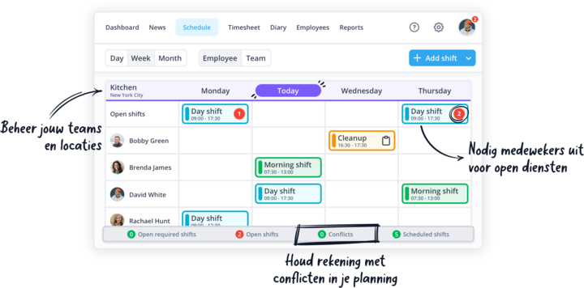

TEST NOW FOR FREE

