Shiftbase Template
Shift Workers Employment Contract


EMPLOYMENT CONTRACT TEMPLATE
For Shift Workers | UK

Important notice
This template is a practical starting point, not a substitute for legal advice. Employment law changes regularly. Always verify current requirements with ACAS (acas.org.uk) and GOV.UK, and consider having a qualified employment solicitor review any contract before use.
This template covers England, Wales, and Scotland. Northern Ireland has separate employment legislation.

1. Parties to this contract
Complete the fields below before issuing this contract.

Employer name
Employer address
Employee name
Employee address
Job title
Department / location
Employment start date
Continuous employment date | If different from start date
Contract type | Permanent / Fixed-term / Zero-hours (delete as applicable)
Fixed-term end date | If applicable — state end date or objective condition

2. Employment type and status
[Employee name] is employed as [Job Title] with effect from [Start Date].

Select the applicable contract type and delete the others:

PERMANENT: This is a permanent contract with no fixed end date. Employment will continue until terminated by either party in accordance with the notice provisions in Section 9.

FIXED-TERM: This contract is for a fixed term ending on [End Date] / upon [objective condition, e.g. return of [Name] from maternity leave / end of the Christmas trading period]. At the end of the fixed term, employment will cease unless the parties agree otherwise in writing.

ZERO-HOURS: This contract does not guarantee any minimum number of hours. The employer will offer shifts as available. The worker is under no obligation to accept any particular shift. No exclusivity applies: the worker is free to work for other employers.

3. Hours of work and shift arrangements
This section is the most important shift-specific departure from a standard template. Complete carefully.

3.1 Variable hours clause
The nature of the business means that working hours vary according to operational requirements. [Employee name]'s hours will be as required by the business and communicated via the shift schedule. [There is no fixed weekly minimum / The minimum guaranteed hours per week are [X].] (delete as applicable)

3.2 Shift schedule and notice
Shifts will be communicated via [Shiftbase / the scheduling system / [other method]] with a minimum of [one week's / [X] days'] notice wherever reasonably practicable. The employer will endeavour to provide reasonable notice of schedule changes, but operational circumstances may require shorter notice on occasion.

3.3 Flexibility clause
The employer reserves the right to vary [Employee name]'s shift pattern, including the days and times worked, with reasonable notice to reflect operational needs. Where a permanent change to regular shift patterns is proposed, the employer will consult with the employee before implementing the change.

3.4 Shift swaps
[Employee name] may request to swap a shift with an eligible colleague. All shift swaps require prior written approval from [manager / the scheduling manager] before the swap takes effect. Unapproved swaps do not alter the employee's contractual obligations.

4. Pay and shift premiums

4.1 Basic rate
Hourly rate / salary
Payment frequency | Weekly / fortnightly / monthly (delete as applicable)
Payment method | BACS to employee's nominated bank account

4.2 Shift premiums (complete if applicable)
Delete any rows that do not apply.

Premium type | Rate / uplift | When it applies
Night shift enhancement | [Enter rate] | e.g. shifts between 22:00 and 06:00
Weekend premium | [Enter rate] | e.g. Saturday and/or Sunday shifts
Overtime rate | [Enter rate] | e.g. hours above [X] per week
Bank holiday rate | [Enter rate] | e.g. [X] times standard rate

5. Working time and rest periods
The Working Time Regulations 1998 apply to this contract. The employer and employee agree to the following:

Rest between shifts | A minimum of 11 consecutive hours' rest between the end of one shift and the start of the next.
Weekly rest | At least 24 hours' uninterrupted rest in each seven-day period, or 48 hours in each 14-day period.
Shift break | An uninterrupted rest break of at least 20 minutes when the working day exceeds six hours.
Night work limit | Where [Employee name] regularly works at least three hours of their daily working time between 23:00 and 06:00, the average working time for night periods will not exceed eight hours per 24-hour period, calculated over a 17-week reference period.
Night work health assessment | Night workers are entitled to a free health assessment before being assigned to night work and at regular intervals thereafter. [Employee name] will be offered such an assessment upon request.

6. Holiday entitlement and holiday pay

6.1 Entitlement
[Employee name] is entitled to [5.6 weeks / [X] days] of paid annual leave per leave year, which runs from [1 January to 31 December / other]. The statutory minimum is 5.6 weeks (28 days for a full-time employee working five days per week).

6.2 Holiday pay calculation
Holiday pay will be calculated to reflect normal remuneration, which includes regular overtime, shift premiums, and any other payments that form part of the employee's normal working pattern. Holiday pay will not be limited to basic hourly rate alone where the employee regularly works additional hours or receives shift premiums.

For employees with genuinely irregular hours, holiday pay will be calculated based on the average weekly pay over the preceding 52 weeks in which the employee was paid (or fewer, if employed for less than 52 weeks).

6.3 Booking and approval
Holiday must be requested via [Shiftbase / the scheduling system / [other method]] with a minimum of [two weeks'] notice. Approval is subject to operational requirements. The employer reserves the right to require employees to take holiday at specified times, including [shutdown periods / peak trading periods], with appropriate notice.

7. Absence and sick leave

7.1 Reporting absence
If [Employee name] is unable to attend a scheduled shift, they must notify [manager name / the scheduling manager] by [telephone / the Shiftbase app / [other method]] as soon as reasonably practicable, and no later than [one hour] before the shift start time.

7.2 Statutory Sick Pay
Statutory Sick Pay (SSP) will be paid in accordance with the applicable legislation. [The employer offers [X] weeks of enhanced sick pay at [full / half] pay per rolling 12-month period, subject to the employee's absence management record.] (delete if enhanced sick pay does not apply)

8. Pension
[Employee name] will be automatically enrolled into the employer's workplace pension scheme when eligible under the automatic enrolment legislation. Current minimum contribution rates are [X]% employer and [X]% employee. The employer's pension provider is [Provider name]. Full details are set out in the pension scheme documentation.

9. Notice periods
Notice from employer | The statutory minimum is one week per complete year of continuous employment, up to a maximum of 12 weeks. [The employer will give [X] weeks' notice, subject to the statutory minimum.]
Notice from employee | [One week / [X] weeks / [X] months] written notice.
During probation | [One week's notice from either party during the probationary period of [X] months / No probationary period applies.] (delete as applicable)
Payment in lieu | The employer reserves the right to make a payment in lieu of notice rather than require the employee to work their notice period.

10. Other terms
Place of work | [Principal place of work]. The employer may require the employee to work at other locations with reasonable notice.
Probationary period | [X months] / Not applicable (delete as applicable)
Confidentiality | The employee must not disclose confidential business information during or after employment without the employer's written consent.
Data protection | Employee data will be processed in accordance with the employer's privacy notice, provided separately.
Governing law | This contract is governed by the law of England and Wales / Scotland (delete as applicable).
Collective agreements | There are no collective agreements in force that affect this contract. / [Details of any applicable collective agreement.] (delete as applicable)
Whole agreement | This contract constitutes the entire agreement between the parties in respect of the employee's employment and supersedes any previous agreements or representations.

11. Policies and procedures
The following policies and procedures form part of the employee's terms and conditions of employment. Copies are available from [manager / HR / the company intranet]:

- Disciplinary procedure
- Grievance procedure
- Absence management policy
- Health and safety policy
- [Any other applicable policies]

12. Signatures
By signing below, both parties confirm they have read, understood, and agree to the terms of this contract.

On behalf of the employer  Signature  Full name (print)  Date | Employee  Signature  Full name (print)  Date

APPENDIX: SHIFT-WORKER CONTRACT CHECKLIST
Use this checklist to verify your contract before issuing it. Every clause marked Statutory is legally required. Every clause marked Shift-specific is critical for shift-based operations.
Clause | What to include | Type
Job title and duties | Role, responsibilities, and any flexibility on duties | Statutory
Start date | Employment start date; continuous employment date if different | Statutory
Pay and payment frequency | Hourly rate or salary; when and how they are paid | Statutory
Holiday entitlement | At least 5.6 weeks statutory minimum stated | Statutory
Sick pay | SSP minimum; enhanced sick pay if offered | Statutory
Notice periods | Both employer and employee notice stated | Statutory
Pension | Auto-enrolment eligibility and contribution rates | Statutory
Grievance and disciplinary | Reference to employer's procedure included | Statutory
Place of work | Principal location stated; mobility clause if applicable | Statutory
Variable hours clause | No fixed weekly figure unless a contractual guarantee is intended | Shift-specific
Schedule communication | How and when shifts are communicated; minimum notice stated | Shift-specific
Flexibility clause | Employer's right to vary shift patterns; notice and process stated | Shift-specific
Fixed-term clause | End date or objective condition; what happens at expiry | Shift-specific
Zero-hours clause | Right to turn down shifts; no exclusivity (required by law) | Shift-specific
Shift premiums | Night, weekend, and overtime rates defined; how calculated | Shift-specific
Rest periods | 11 hrs between shifts; 20-min break over 6 hrs; one day off/week | Shift-specific
Night work provisions | Health assessment entitlement; 8-hour average maximum | Shift-specific
Shift swap process | How swaps are requested; manager approval required | Shift-specific
Holiday pay calculation | Reflects normal pay incl. regular overtime and shift premiums | Shift-specific
Absence reporting | How and when to report; contact method and deadline | Shift-specific

Key legal references
Employment Rights Act 1996 — written statement of particulars required from day one
Working Time Regulations 1998 — rest periods, night work limits, break entitlements
Fixed-term Employees (Prevention of Less Favourable Treatment) Regulations 2002 — four-year rule
Workers (Predictable Terms and Conditions) Act 2023 — right to request predictable hours after 26 weeks
GOV.UK: gov.uk/employment-contracts-and-conditions
ACAS: acas.org.uk/templates-for-written-statements

Template provided by Shiftbase | shiftbase.com | Not a substitute for legal advice. Verify current requirements at gov.uk and acas.org.uk before use.

Try Shiftbase 14 days for free
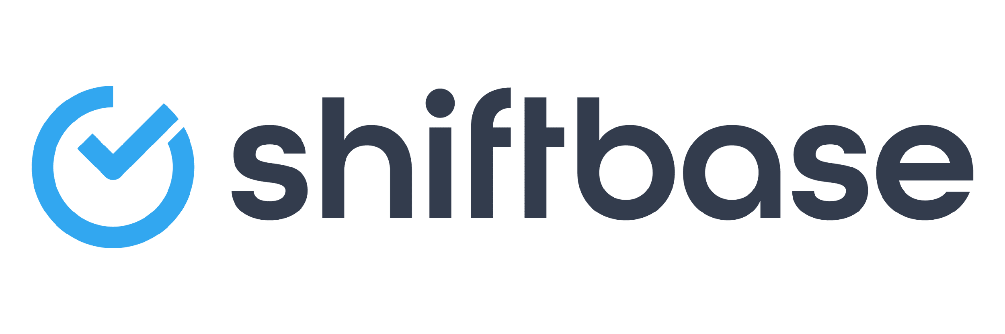
TRY SHIFTBASE FOR FREE AND WITHOUT OBLIGATION FOR 14 DAYS
Discover the comprehensive HR features of Shiftbase and see how you can manage all your employee data in one place. With Shiftbase, you can create detailed analyses of your business performance, gaining valuable insights into your company. Benefit from customizable reports and dashboards that provide you with a real-time overview of your entire company. Experience for yourself how Shiftbase simplifies your HR processes and optimizes your company management.
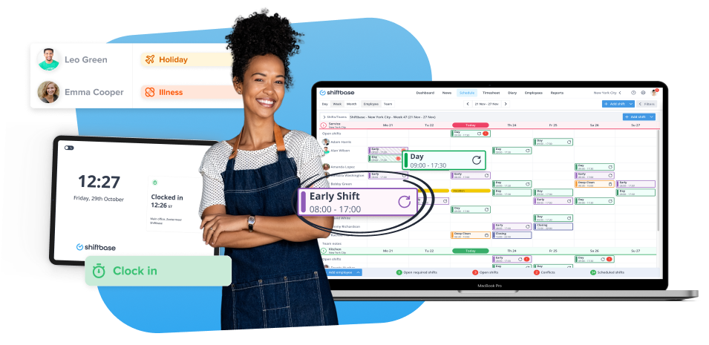
TRY IT NOW FOR FREE

