Shiftbase sample template
Sickness reporting protocol


About this sample template

A clear and unambiguous sick leave protocol is a key component of a transparent and reliable HR organization. By pre-defining how and when employees report sick and the steps to follow, you prevent confusion, misunderstandings, and differing interpretations within the organization.

This sample template will help you create a sick leave protocol that provides clarity for both employees and managers. The template provides a structured framework that includes reporting procedures, responsibilities, communication, availability, and sick leave documentation.

This template will help you create a legally sound protocol that remains practically applicable. Whether you're establishing sick leave agreements for the first time or want to update an existing protocol, this template will help you arrive at clear and consistent agreements.

Sick reporting protocol

1. Purpose and scope
This protocol describes how employees report sick and how sick leave is tracked and recorded within the organization. The purpose of this protocol is to ensure business continuity, clarify responsibilities, and ensure that sick leave is handled carefully within applicable laws and regulations.

2. Scope
This protocol applies to all employees who work according to a schedule and who report as fully or partially incapacitated for work due to illness.

3. General principles
- A sick report must always be made personally by the employee, unless this is not reasonably possible.
- A sick leave report relates exclusively to the employee's incapacity for work and not to the cause thereof.
- No rights can be derived from this protocol by employees.
- When processing sick reports, the organization acts in accordance with applicable privacy legislation.

4. Conditions for exchanging a service
- An employee reports sick under the following conditions:
- The sick report is made through the channel designated by the organization.
- The sick report must be made as soon as possible, but no later than[enter time]prior to the next scheduled service.
- When reporting sick, the employee states for which service(s) he or she is reporting sick.
It is not permitted to report illness via non-designated channels unless other arrangements have been made in advance.

5. Responsibilities after reporting sick
- The employee is responsible for reporting illness correctly and in a timely manner.
- The planner is responsible for assessing the consequences of the sick leave notification for the planning and the necessary follow-up steps.
- The organization determines whether and how replacement is arranged.

6. Recording and registration
- Every sick report is immediately recorded in the schedule.
- Oral or individual reports are always administratively recorded.
- The recording of sick leave reports takes place in compliance with the applicable privacy rules.

7. Absence and availability

The employee remains available to the organization during the illness, to the extent that this can reasonably be expected.

If the illness lasts longer than initially reported, the employee must inform the organization of this in a timely manner.

8. Deviations and unforeseen situations
In cases not covered by this protocol, the organization will decide. Deviations from this protocol will be recorded.

9. Entry into force and amendment
This Protocol shall enter into force on [date]and can be changed by the organization at any time. Changes will be communicated to employees in a timely manner.

Try Shiftbase free for 14 days.

Discover Shiftbase's comprehensive HR features and learn how to manage all your employee data in one place. With Shiftbase, you can perform detailed analyses of your business performance and gain valuable insights into your business. Benefit from customizable reports and dashboards that give you a real-time overview of your entire company. Experience firsthand how Shiftbase simplifies your HR processes and optimizes your operations.
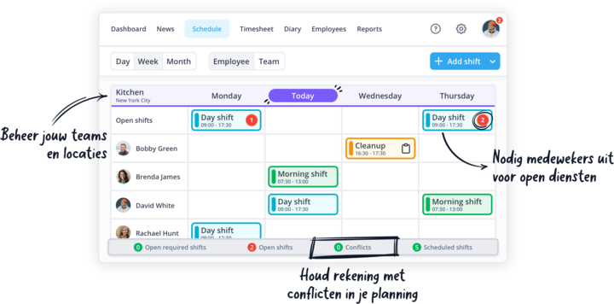

TEST NOW FOR FREE

